Berrien Fire Chief’s Association

Meeting 7-18-18

Called to order by Chief Davidson at 1830 hours

ATTENDANCE:  TREASURER’S REPORT – Chief Lamb reported the Checking at $2505.10. Motion, second with all in favor.  MINUTES – June 20, 2018 minutes were presented. Motion, second, with all in favor.  COMMUNICATIONS / BILLS –  Chief Doug Meyers from Covert wanted to make sure everyone knew about their department’s open house on July 28 at 10am.  North Berrien will be flipping Pancakes on August 4-5 for Glad Peach Festival. | 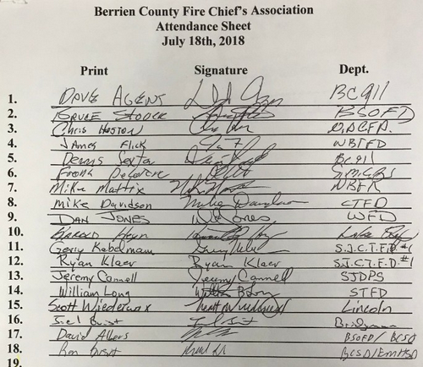

PRESENTATION – .

COMMITTEE REPORTS

SHERIFF-. The Sheriff discussed their efforts this season to keep the beach family friendly. Teaming up with St Joe Public Safety. Red BudDDD International event effort being planned as well as getting ready for the Youth Fair. He reminded everyone that his department only has 2 Deputies assigned to the fair. All of the others are volunteers giving back to the community. Finally the Life Rings were briefly discussed. Both the SD and SJPS officers are checking to make sure they remain ready to go.

911 –.Director Agens is preparing to sign an MOU to take responsibility for the Niles Communication Equipment with the State and Motorola making any repairs. Dave discussed future charges pending on colocation of VHF equipment on State Towers. He is proposing to move New Buffalo City and Township to 800 pagers now. The initial proposal would be 911 to fund 50% of the cost of the new pagers. Benton Harbor City is having good luck so far with the new system and Saint Joe City is in the planning stages to migrate soon. Dave wants to be fair with all agencies. The group felt that with the issues in the New Buffalo area it made financial sense to help fund this move. It would provide long term savings by illuminating the need for at least one phone link saving money in the long run. Plans are still in the works for another run at the large grant when it’s again released.
Chief Heyn discussed interference that he has been having. Dave said that it was most likely interference in the area and that short of calling the FCC not an easy fix. Colocation agreements could cause issue. VHF competing with a stronger system. Simulcast helps this issue. Sumnerville Tower to Bertrand Tower microwave link radios require replacement. Clocks will also soon need to be replaced at a sizable expense.

DNR –. None

Funeral Protocol – 150 badge straps ordered.

EMERGENCY MANAGEMENT/LEPC –..Sgt Bush discussed flooding and the United Way long term recovery work group to fund and meet unfunded needs. Application for low interest loans has closed. After Action report request from Rockey has been sent out. Please look it over and fill out any sections that applies to your organization. Moving forward with BWarn. Active Violence Deputy Albers working with RTF development. 5 people are going to Train the Trainer.

LEPC had Dr. Harvey Barnett speak on responder mental health and the availability of the County CISM team when we need them.

TRAINING- Dave Albers presented a survey and instructions for proposed training needs. Please turn it in to let them know what you would like to see in the way of future training in our County. Courage to be safe, First Aid can be presented by training or Aaron Floor in Niles Township.
August 4 at St Joe High School a “Pride in Ownership” with Nationally Acclaimed instructor Chief Lasky with Lunch also provided.

Proposed schedule for future FF1&2 is now out. The committee decided to present the bulk of the class on the weekends with the option of Days being provided in Cass County on Tuesday and Thursday.
.
FAIR- Both Gerry and Bruce are still looking for help with Fire Prevention and Standby and inspection services.

HazMat- None

BCFA –.

EMS-
SMCAS – Made it through Red Bud – 3 patients required transport. Very light due to positive weather. Internationals due up in October with more requirements coming from their sanctioning body on EMS.
MEDIC- None
MED Flight – None
Dr. Beyers- None

Mi-TRT-5 – Keep the team in mind and call them to these advanced rescues. It’s Free and the guys on the team need to be exercised. Can avoid future legal questions.

MABAS-..Frank asked that all MABAS Depts. provide contacts for 2 members from each department so that they can have access to the MABAS Website. He reported that MABAS will also have a presence at the upcoming UP Games.

New box card templets on website. Departments are asked to update to the new card by December 31st. Take the opportunity to review cards and make any adjustments. MI Chiefs will have a MABAS Track at their upcoming conference. Huron Valley will be the new MABAS Red Center taking over for Livingston County. Finally MABAS is growing into the UP with Menominee County joining MABAS as the first UP division.
.

OLD BUSINESS -. Fair letter went out yesterday asking for assistance. 3 Special events included. Continual water retention improvements ongoing. Contact Chief Stover.

Bruce will start working on the grant soon. He will need an additional year of date from all agencies when he puts it together. He is confident that the issues that plagued our submittal last year have been identified and will be addressed in this future request.

NEW BUSINESS –.. Dave White has a new camera and would like to shoot your new apparatus.

Andrews Dairy will be shutting down.

Rescue Task Force (RTF) discussed.

Motion of Adjournment. Next Meeting. Youth Fair Grounds @ 0830 on August 15.

RS Larry Lamb



